**TWO LIMONOIDS FROM THE SEEDS OF *Chisocheton macrophyllus* AND**

**THEIR CYTOTOXIC ACTIVITY AGAINST MCF-7 BREAST CANCER CELLS**

Intan Rahmayanti1, Nurlelasari1*, Desi Harneti1, Rani Maharani1,2, Darwati1,

Yoshihito Shiono3, Unang Supratman1,2

1Department of Chemistry, Faculty of Mathematics and Natural Sciences,

Universitas Padjadjaran, Jatinangor 45363, Indonesia

2Central Laboratory, Universitas Padjadjaran, Jatinangor 45363, Indonesia

3Department of Food, Life, and Environmental Science, Faculty of Agriculture,

Yamagata University, Tsuruoka, Yamagata 997-8555, Japan.

Corresponding author, Telp/Fax: +6285722368244/022-7794391

Email address: [nurlelasari@unpad.ac.id](mailto:nurlelasari@unpad.ac.id)

|  |  |
| --- | --- |
| Table of Contents | Page |
| **Figure 1.** HR-TOFMS of (**1**) | 2 |
| **Figure 2.** 1H-NMR Spectrum of (**1**) (500 MHz in CDCl3) | 3 |
| **Figure 3.** 13C-NMR and DEPT-135° Spectra of (**1**) | 4 |
| **Figure 4.** HMQC Spectrum of (**1**) | 5 |
| **Figure 5.** 1H-1H COSY Spectrum of (**1**) | 8 |
| **Figure 6.** HMBC Spectrum of (**1**) | 11 |
| **Figure 7.** HR-TOFMS of (**2**) | 17 |
| **Figure 8.** 1H-NMR Spectrum of (**2**) (500 MHz in CDCl3) | 18 |
| **Figure 9.** 13C-NMR and DEPT-135° Spectra of (**2**) | 19 |

|  |  |
| --- | --- |
|  |  |

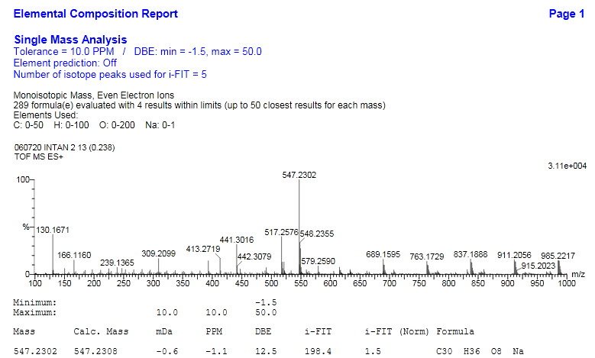

**Figure 1.** HR-TOFMS of (**1**).

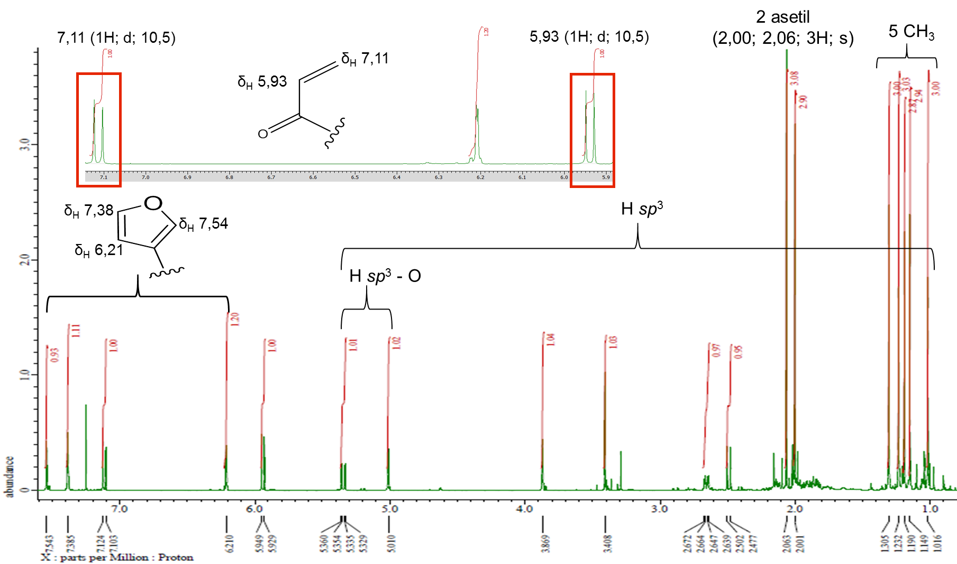

**Figure 2**. 1H-NMR Spectrum of (**1**) (500 MHz in CDCl3).

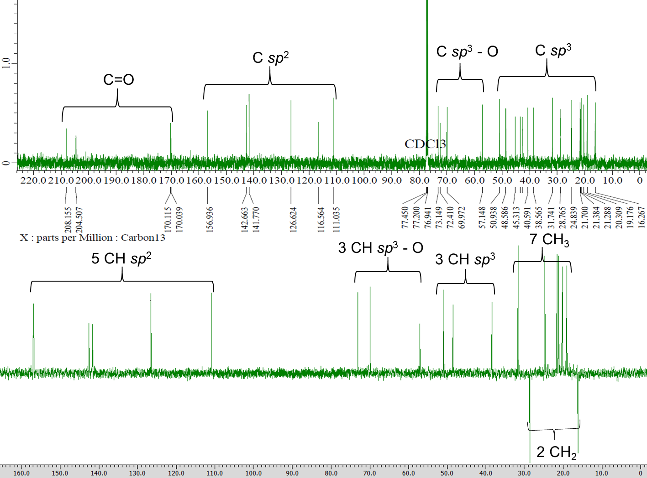

**Figure 3**. 13C-NMR and DEPT-135° Spectra of (**1**).

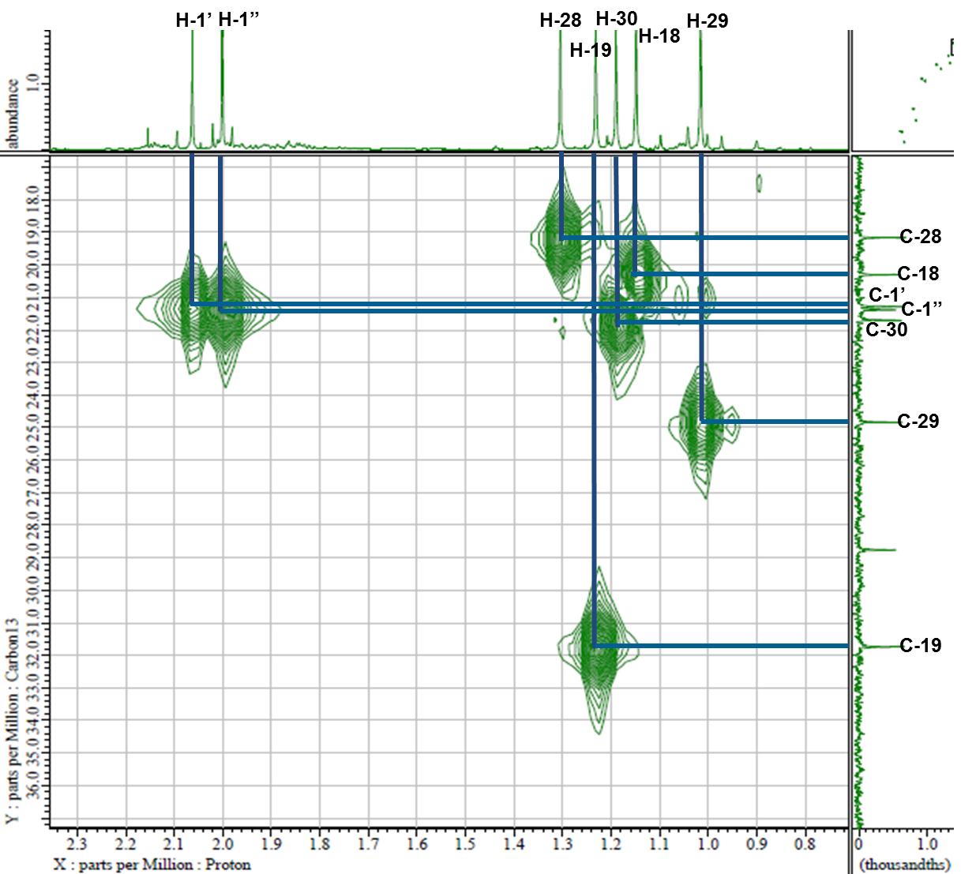

**Figure 4**. HMQC Spectrum of (**1**).

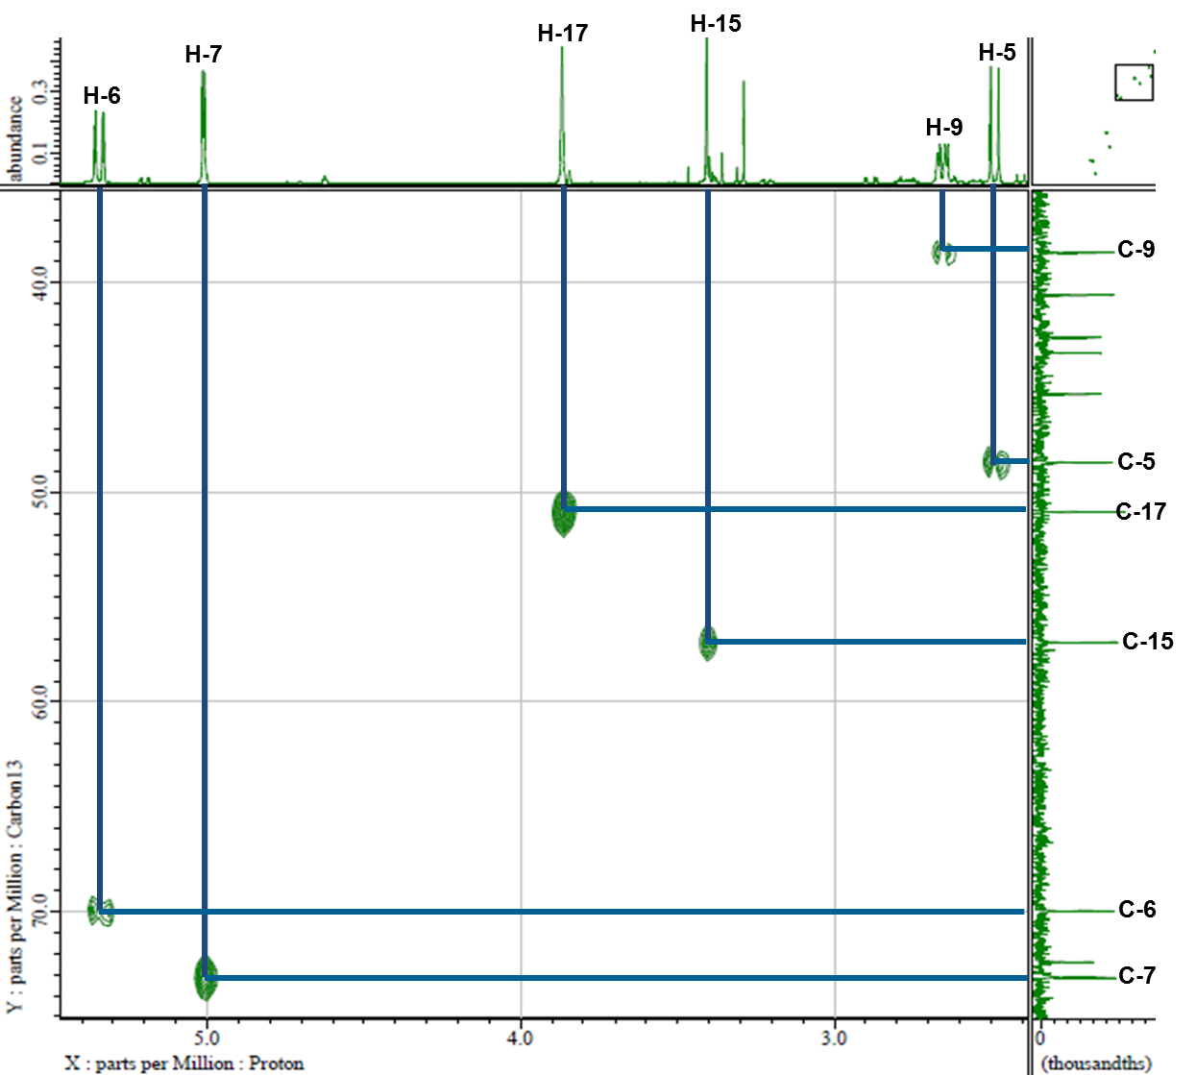

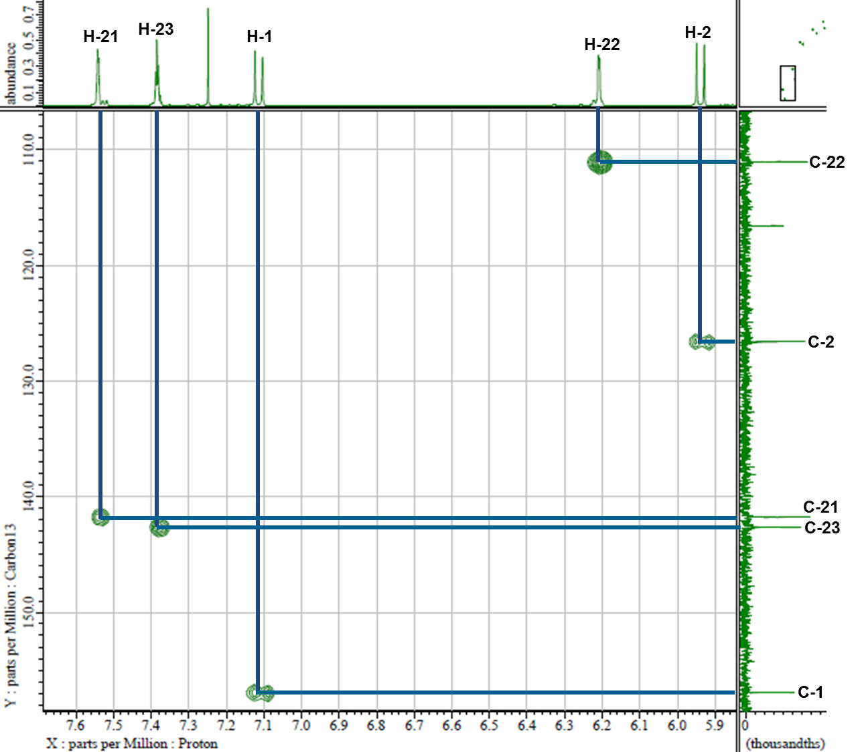

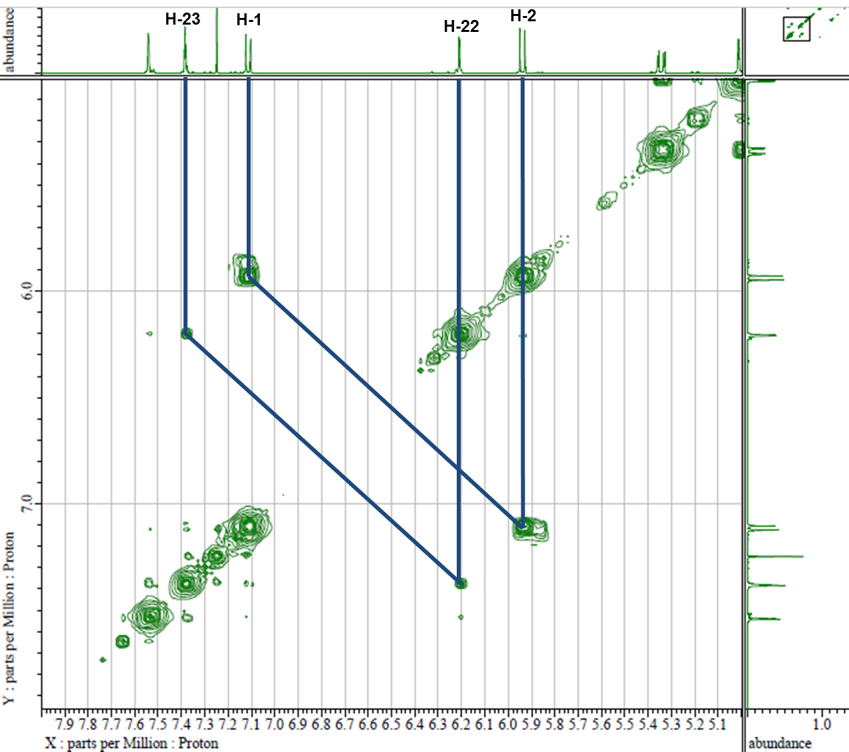



**Figure 5**. 1H-1H COSY Spectrum of (**1**).

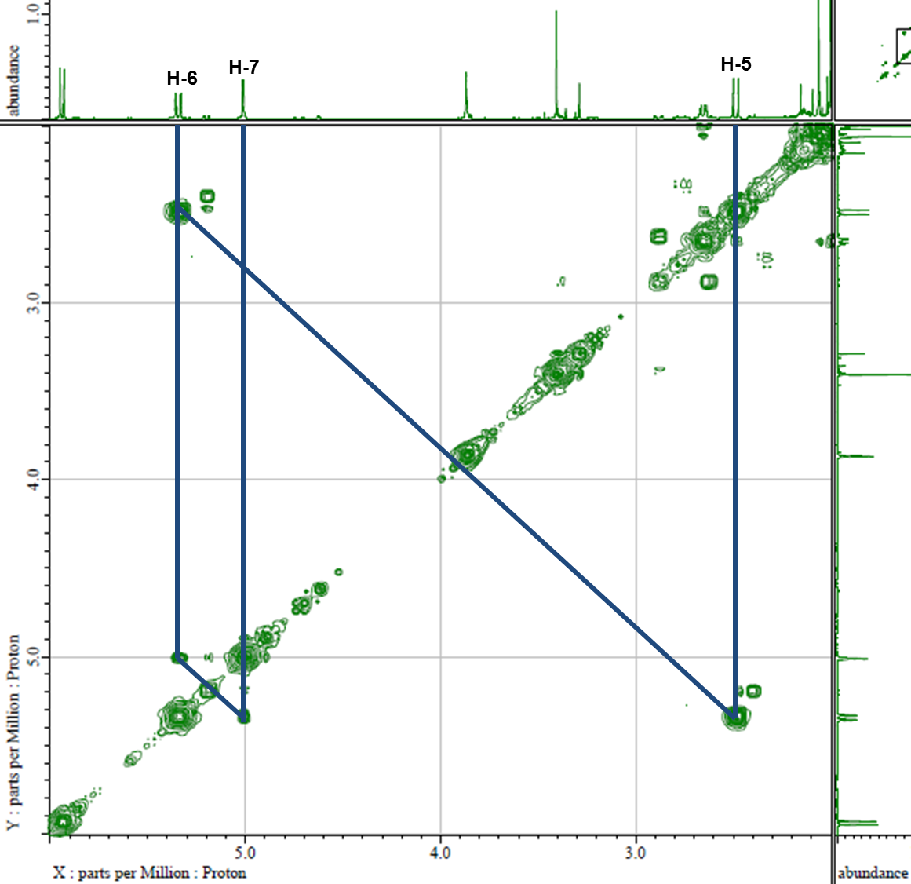



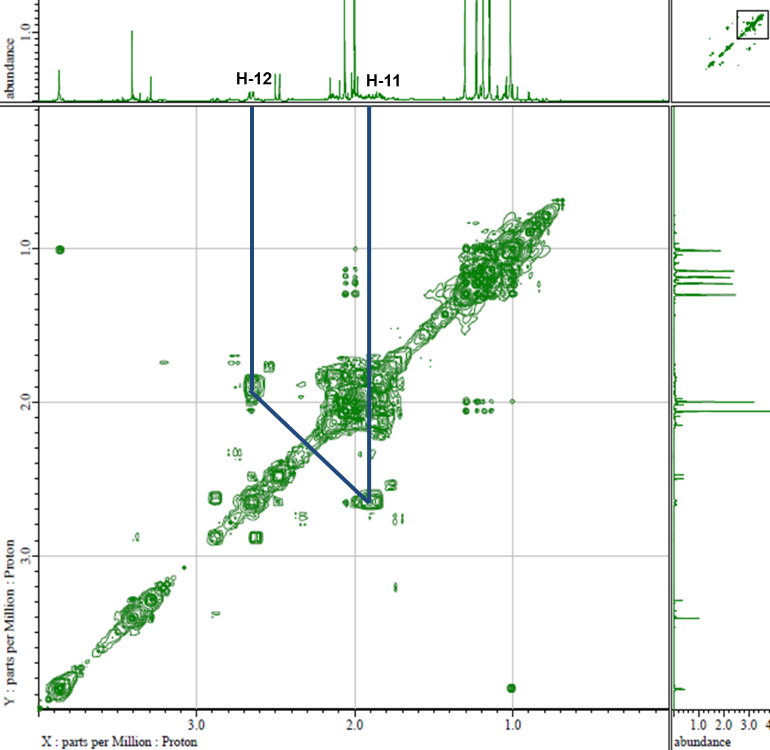



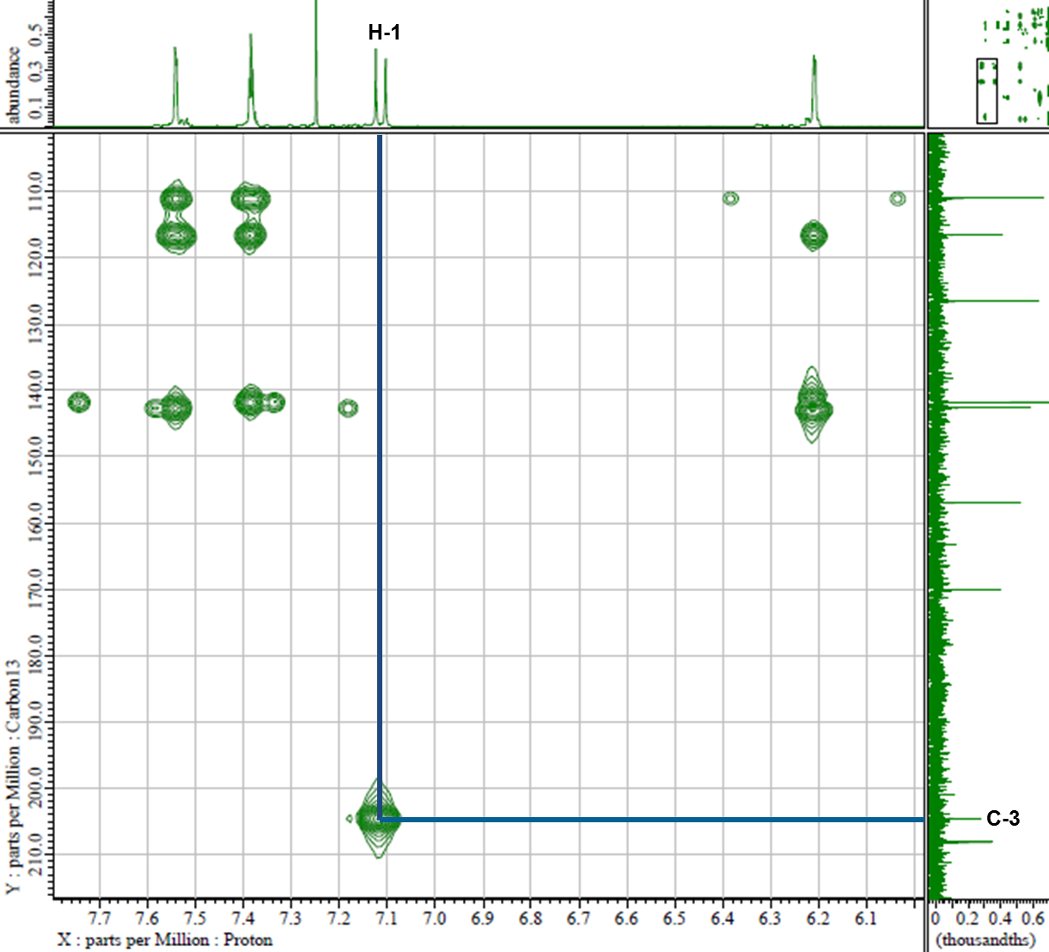



**Figure 6**. HMBC Spectrum of (**1**).

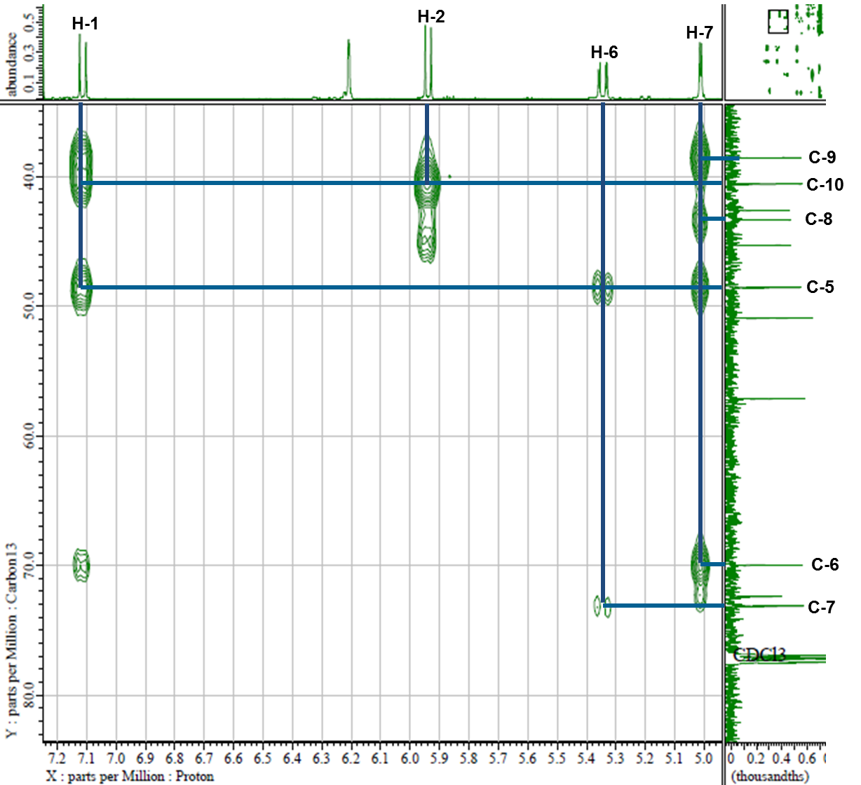



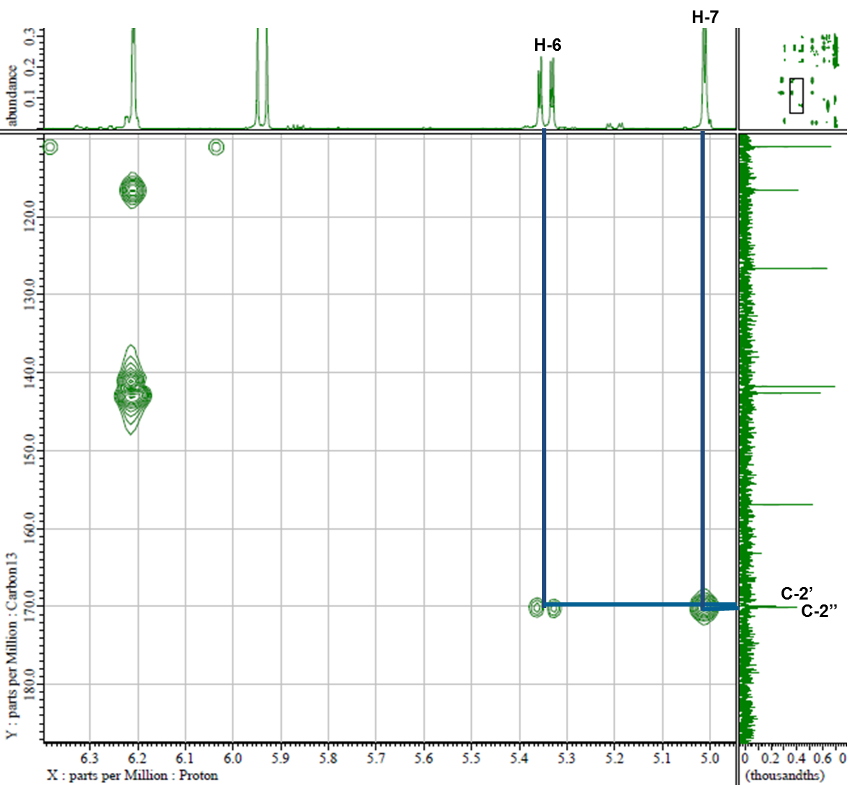



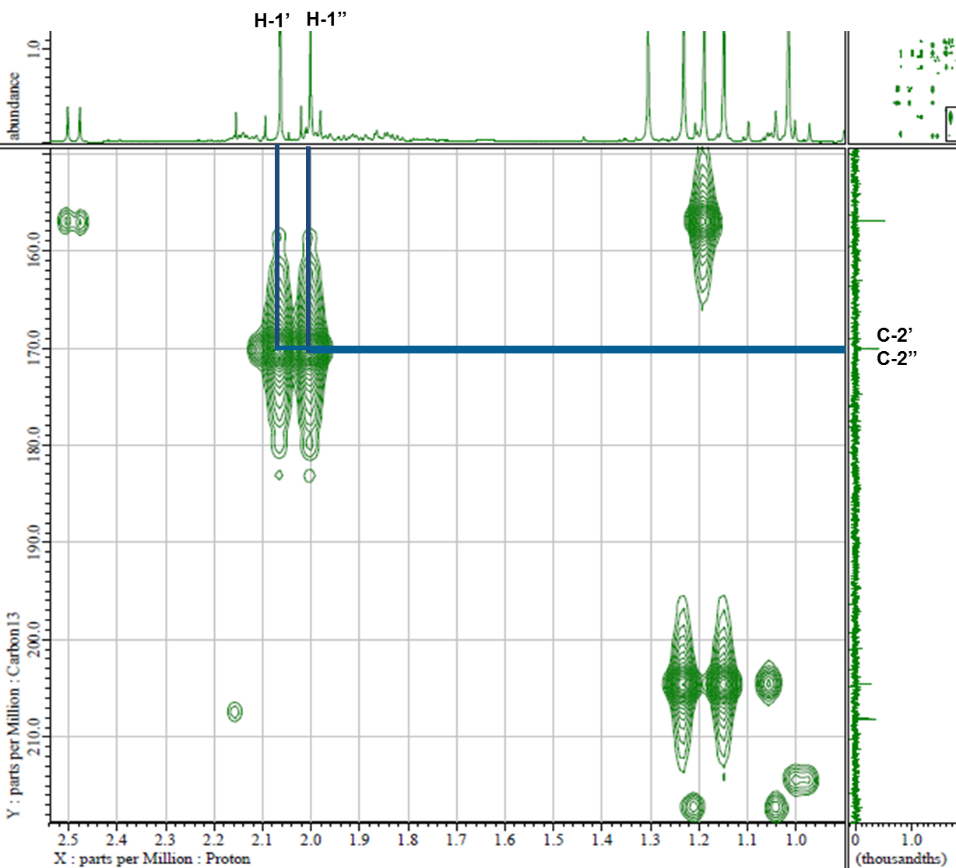



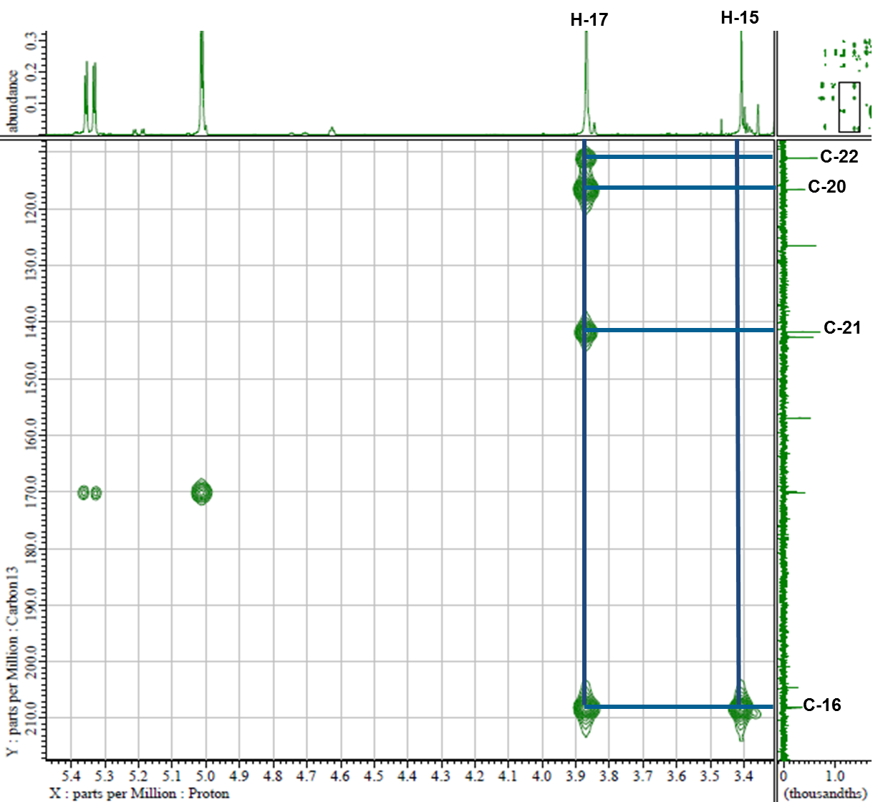



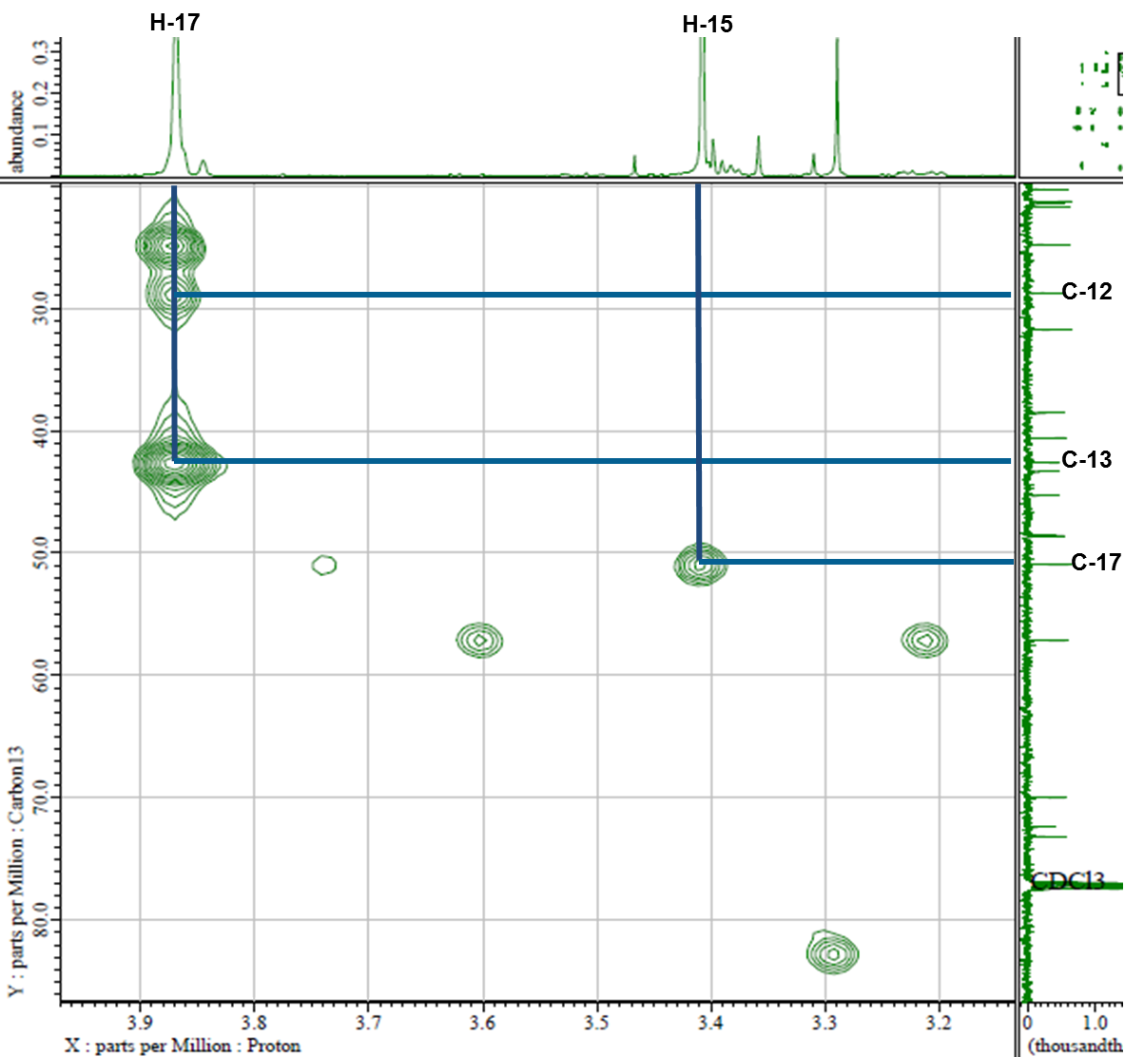



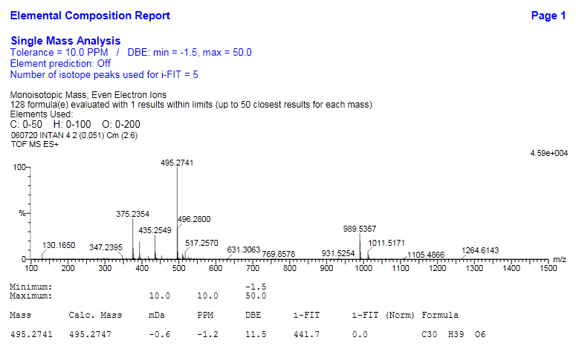

**Figure 7.** HR-TOFMS of (**2**).

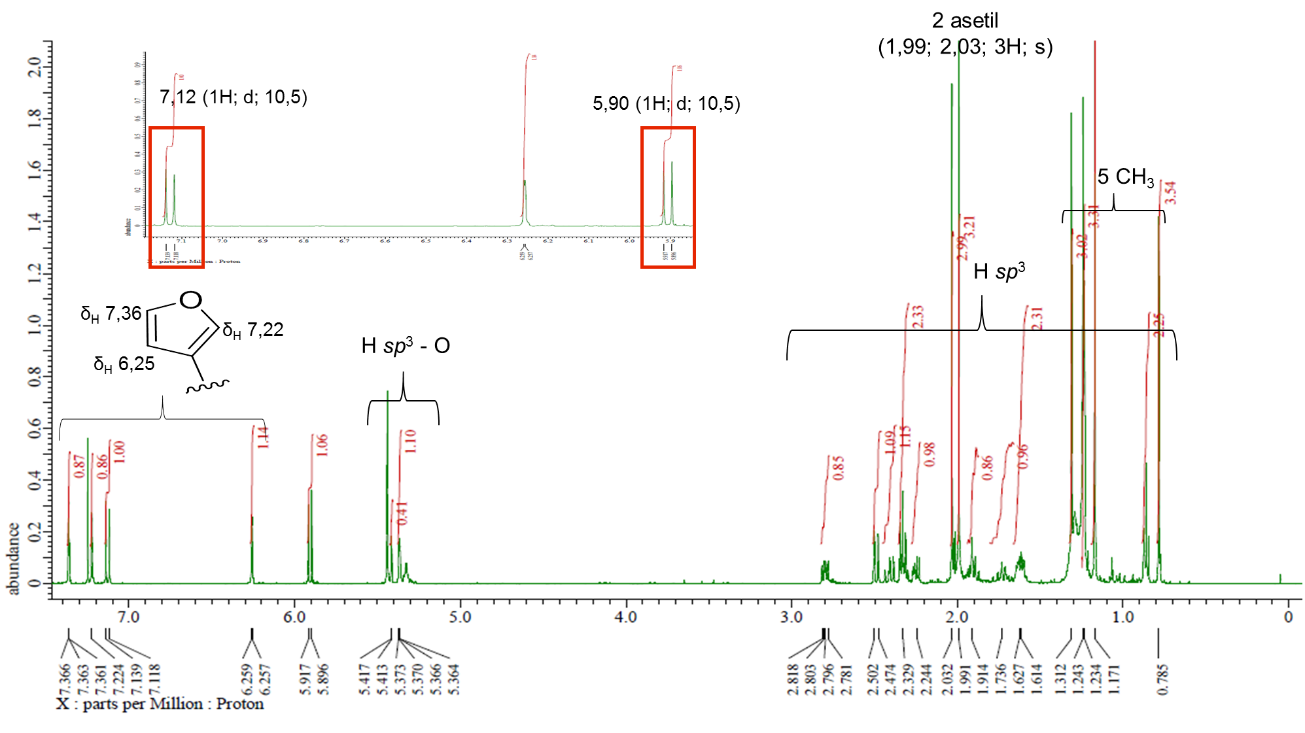

**Figure 8.** 1H-NMR Spectrum of (**2**) (500 MHz in CDCl3).

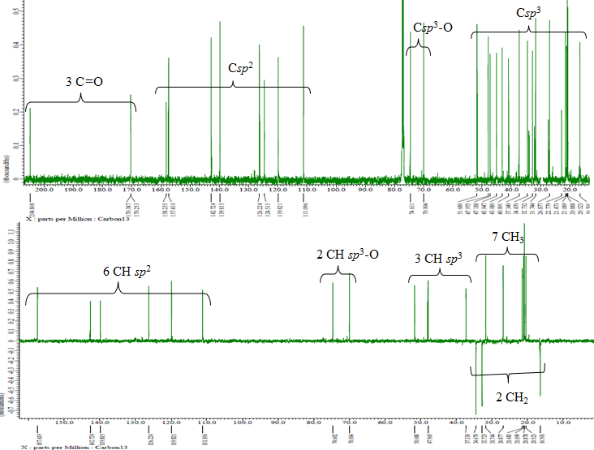

**Figure 9.** 13C-NMR and DEPT-135° Spectra of (**2**).